**Lab 12: Android Sensors**

# **Introduction**

The majority of android devices come equipped with sensors that can detect motion, direction, and various environmental factors. These sensors will offer highly accurate raw data, which can be used to track changes in the surroundings close to a device or to track the movement or positioning of a device in three dimensions.

**Let’s get Started:**

In this Exercise we will be implementing to identify the sensors and list all the available sensors on a device using android sensor framework.

**Step 1:** open newly created xml (**options_menu.xml**) file and write the code like as shown below.

**options_menu.xml**

<?xml version="1.0" encoding="utf-8"?>  
<LinearLayout xmlns:android="http://schemas.android.com/apk/res/android"  
android:orientation="vertical" android:layout_width="match_parent"  
android:layout_height="match_parent"  
android:paddingLeft="10dp"  
android:paddingRight="10dp">  
<TextView  
    android:id="@+id/sensorslist"  
    android:layout_width="wrap_content"  
    android:layout_height="wrap_content"  
    android:layout_marginTop="80dp"  
    android:text="Sensors"  
    android:textSize="20dp"  
    android:textStyle="bold"  
    android:layout_gravity="center"  
    android:visibility="gone"/>  
</LinearLayout>

**Step 2:** Open main [activity](https://www.tutlane.com/tutorial/android/android-activity-lifecycle) file **MainActivity.java** and write the code like as shown below.

**MainActivity.java**

import android.content.Context;  
import android.hardware.Sensor;  
import android.hardware.SensorManager;  
import android.support.v7.app.AppCompatActivity;  
import android.os.Bundle;  
import android.view.View;  
import android.widget.TextView;  
import java.util.List;  
  
public class MainActivity extends AppCompatActivity {  
    private SensorManager mgr;  
    private TextView txtList;  
    @Override  
    protected void onCreate(Bundle savedInstanceState) {  
        super.onCreate(savedInstanceState);  
        setContentView(R.layout.activity_main);  
        mgr = (SensorManager)getSystemService(Context.SENSOR_SERVICE);  
        txtList = (TextView)findViewById(R.id.sensorslist);  
        List<Sensor> sensorList = mgr.getSensorList(Sensor.TYPE_ALL);  
        StringBuilder strBuilder = new StringBuilder();  
        for(Sensor s: sensorList){  
            strBuilder.append(s.getName()+"\n");  
        }  
        txtList.setVisibility(View.VISIBLE);  
        txtList.setText(strBuilder);  
    }  
}

**Step 3: Check Output on Android Emulator and it should look like as given below.**

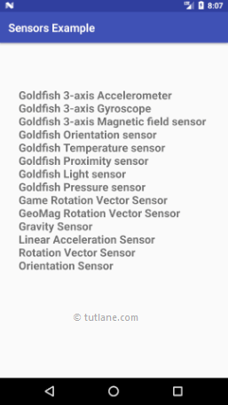

**Voila!!** We have successfully completed this lab.